**KICKSTARTER crowdfunding service**

**Campaigns Analysis**

**Conclusions about Kickstarter campaigns:**

1. From the graph below, it is evident that even after having the highest number of failed projects ‘theater’ is leading with the highest number of ‘successful’ projects (839) making it the most liked and prevalent campaign category.

‘Music’ and ‘Film & Video’ are the next popular campaign categories with ‘music’ having 540 and ‘film & video’ having 300 successful projects.

It also brings forward ‘journalism’ as a completely unsuccessful category with zero successful or live projects and only cancelled projects.

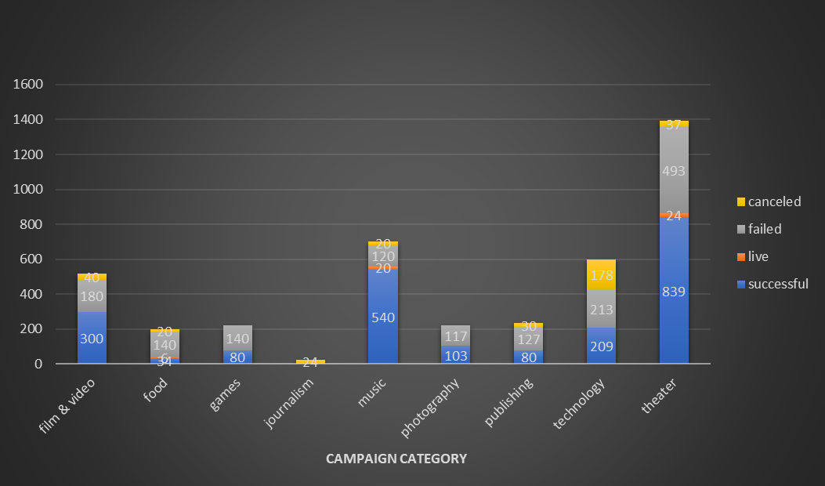

Taking a look at the percentage distribution of states within each category in the graph below, we can see that ‘music’ leads having the highest percentage of successful projects (~77%) and lowest percentage of ‘failed’ projects (~17%) whereas ‘theater’ has ~60% of successful projects and ~35% of failed projects.

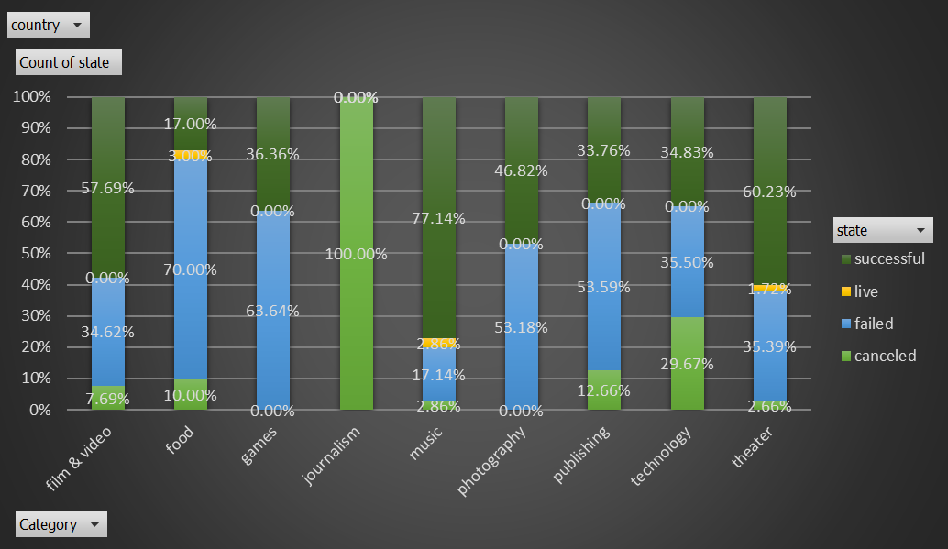

1. The following representation of ‘theater’ sub categories shows ‘plays’ as the biggest hit while ‘animation’ and ‘drama’ being completely failing in raising funds.

Focusing on the overall campaign categories in the graph below, it is clear that ‘music’ is leading with ‘technology’ and ‘film & video” following it as next most liked categories.

1. The timeline of campaign categories shows that the first half of the year has most successful campaigns increasing from January until June and then going down until September that further marks the improvement in the number of successful projects but not being as close as to the high number of successful projects from January to June.

The crowdfunding service, Kickstarter, was relatively slow in the beginning years starting 2009 but improving by a high margin post 2013 with a steep fall in successful number projects in 2017. The year 2017 also has a low number of failed and cancelled project and it could be a result of some financial crisis.

Year 2015 appears to be the most active year in terms of number of projects executed, having the highest number of successful projects and also the highest number of failed and canceled projects.

**Some limitations of the dataset provided**

**No data about the states (regions) contributions:** The dataset provided does not have any information about the states in each country and how different states performed/contributed towards reaching the goal. It would have been helpful to see if certain states are doing better than others to help reach or exceed the goal.

**No information of reason behind failed projects (transparency issues):** The dataset provided mentions failed projects but no reason has been given for the reason behind the failure. The reason for failure can help us understand if there are reasons common across the categories that are failing the projects.

**No information on rewards promised to the donors:** The dataset also does not provide information on what rewards were promised to the donors and if there were certain rewards that were attracting more donors in comparison to others.

**No information of backers who backed out and the reason they did so:** There is no information provided about the number or percent of backers that backed out. This information would have helped us analyze if the number of backers backing out is high and if that is causing cancellation or failure of the projects.

**Ratings of the project and polling the backers to understand their preferences:** The dataset also does not provide the ratings of categories, sub-categories and individual projects within them. There might be certain projects that donors preferred and are more interested in funding.

**Some other possible tables and graphs that we could create**

* The graph showing the duration of each category (by calculating the difference between date created and date ended) and how the duration impacted the project’s success/failure.
* The table showing where each country stands in terms of total goal and total pledged amount so far.

|  |  |  |
| --- | --- | --- |
| **Row Labels** | **Sum of pledged** | **Sum of goal** |
| US | 36182652.57 | 247152380.8 |
| GB | 3498056.14 | 4505048 |
| DE | 1909861.63 | 1989060 |
| CA | 769589.05 | 2490695 |
| AU | 714202.52 | 9901961 |
| ES | 502344 | 8950569 |
| NO | 493022 | 555100 |
| SE | 452442.55 | 13968289 |
| AT | 423984 | 72607 |
| IT | 320039.88 | 1128780 |
| HK | 205035 | 640000 |
| DK | 204294 | 865000 |
| NL | 145121 | 2072050 |
| IE | 141036.23 | 368350 |
| MX | 78160 | 568000 |
| FR | 54677.66 | 426130 |
| NZ | 43644 | 167035 |
| LU | 16065.5 | 13550 |
| SG | 9124 | 9000 |
| CH | 6334 | 104115 |
| BE | 4055.93 | 8750 |
| **Grand Total** | **46173741.66** | **295956469.8** |

* A pie chart showing distribution of different categories in terms of successful and failed projects.
* A table of comparison between sum, max, min and avg of goal and pledged amounts for each category.



* A table or graph of comparison between the data with and without including the outliers to understand how eliminating the outliers impact the results.